B1.2 Domain Trust – SK Review Comments

AuditBoard

Population: Please link to the Population document.

Sampling Methodology:

Please expand to incorporate IA Methodology items in yellow.

*C.2 Sampling Guidelines There are two methods of sample selection: 1) statistical and 2) non-statistical. Statistical sampling uses random numbers to select the sample, which ensures each item in the population has an equal or known chance of being selected. These techniques include independent random sampling, systematic or interval sampling, stratified sampling, to name a few.*

*Non-statistical sampling does not use random numbers to select the sample. Instead, the auditor uses judgment based on an understanding of the population. Such sampling may be done haphazardly. The Audit Team should assess whether the sample is representative of the population and whether sample results can be extrapolated across the entire population. The method of sample selection should be documented in the Audit Board Work Step and each applicable population file.*

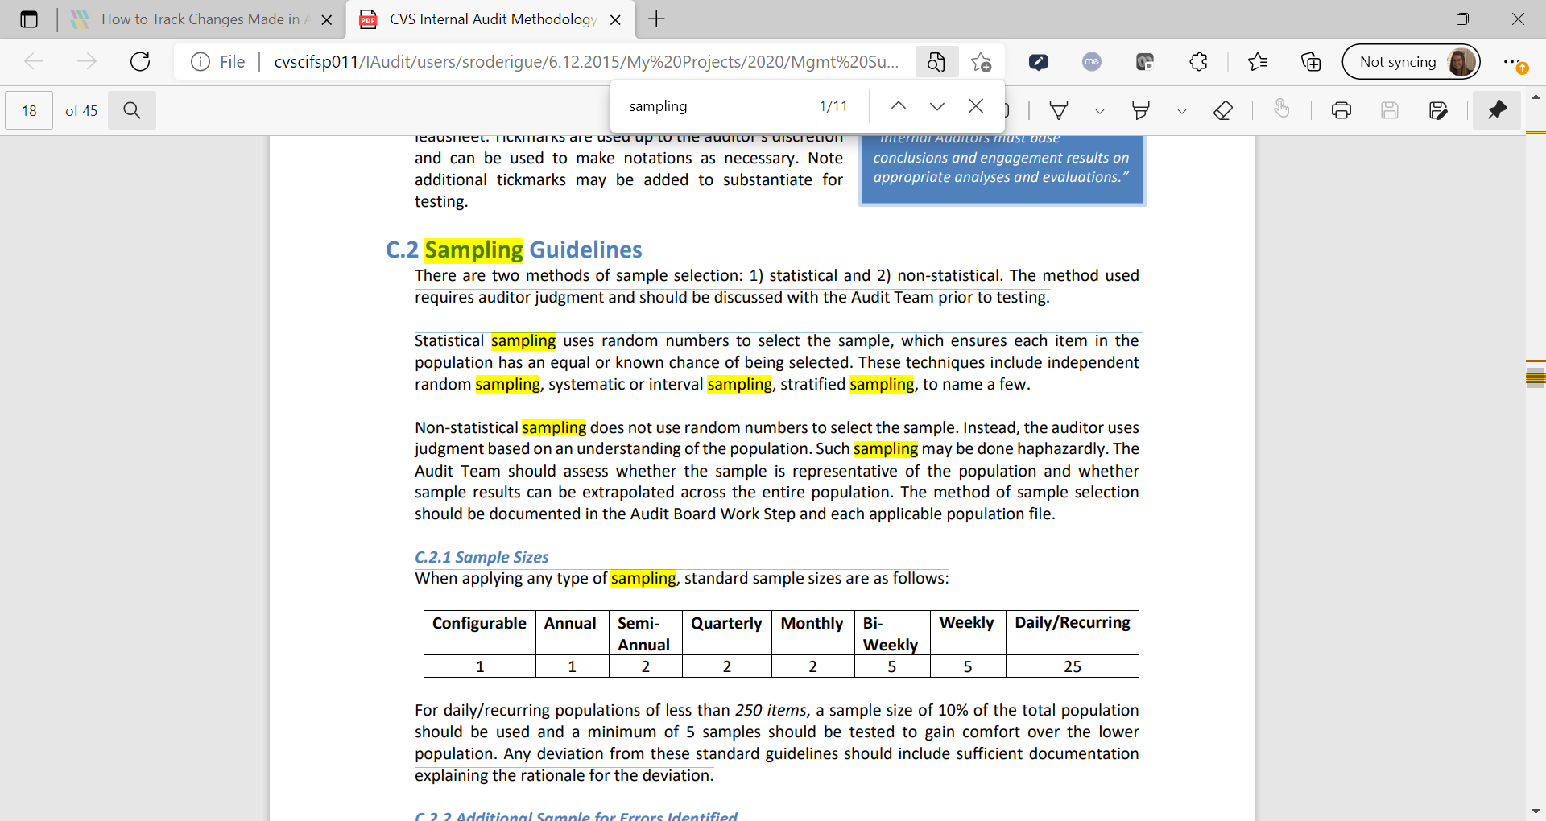

Please expand to incorporate the following details as it relates to C2.1 from Method. Please call out the control frequency we are using (configurable? Daily/recurring?) Sounds like this would be a configurable control which would require a sample size of 1, however we selected 5 to gain additional comfort around the operating effectiveness of the control.

Leadsheet/Leadsheet Support:

Sample 1: Aethna.com Domain however Trust Diagram does not have an Aethna.com Domain listed and the Properties box used to support this test is for Aetna.com domain? Where can I find Aethna.com & Aetna.com Domain on the Trust Diagram (population doc)?

For sample #5 I see a note added around Aeth.aetna.com being a subdomain of Aetna.com which is the forest – please include this same note on the doc used to support sample #1. Why is “Aetna.com” not listed within the forests on Trust diagram?

Sample #3 – minClinic.local and corp.CVS.com indicate no 2-way trust however our diagram indicates there being a 2 way trust – why the discrepancy?